Question 1:
Write a program that asks the user for the size of an integer array, dynamically allocates memory for it, reads integers from the user to fill the array, and then prints all elements. Finally, free the allocated memory.
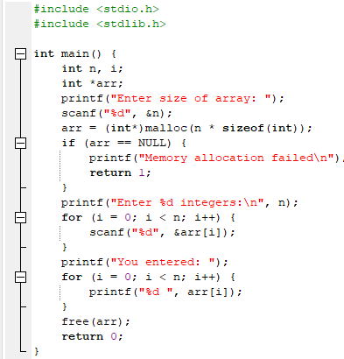
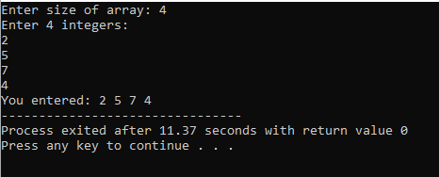
Question 2:
Create a program that dynamically allocates memory for a string, reads a line of text from the user (which can contain spaces), and then prints the string in reverse order. Handle memory allocation properly.
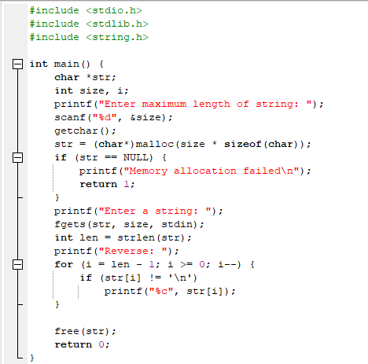
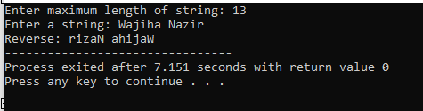
Question 3:
Define a structure Student with name and marks members. Create a dynamic array of Student structures based on user input. Read data for each student and then display students who scored more than 75 marks.
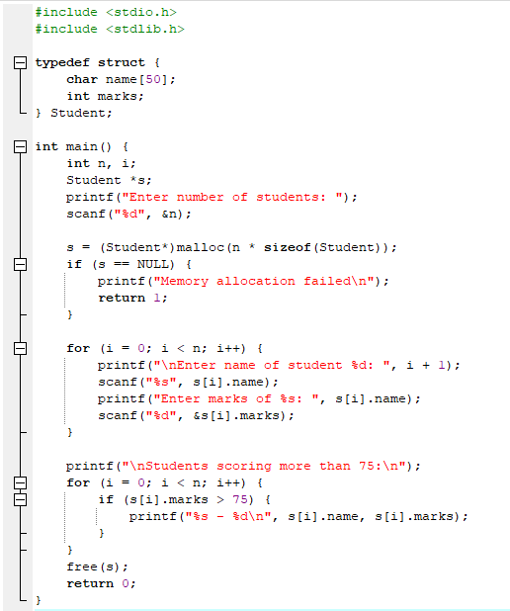
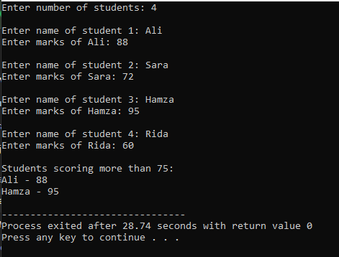
Question 4:
Create an array using calloc (which initializes memory to zero), modify its values, then free it. Immediately reuse the same pointer to create another array using malloc to demonstrate memory reuse.
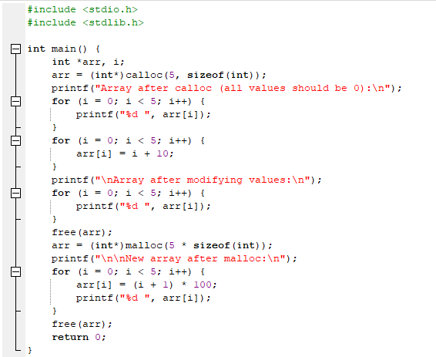
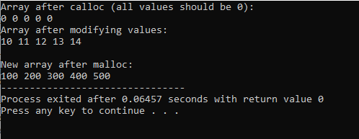
Question 5:
Read two strings from the user, dynamically allocate memory for a third string that will contain the concatenation of both strings, and then display the result.
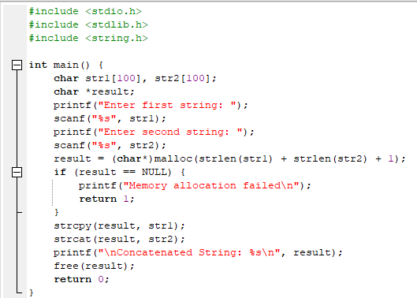
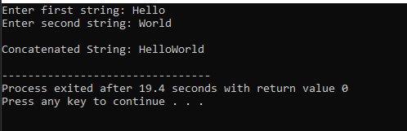
Question 6:
Write a program that calculates the digital root of a number using recursion. The digital root is the recursive sum of all digits until a single digit is obtained. For example, the digital root of 9875 is 9+8+7+5=29, then 2+9=11, then 1+1=2.
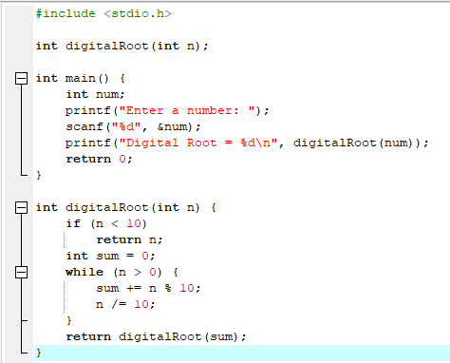
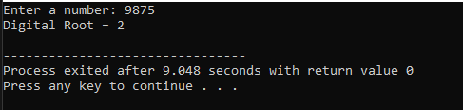
Question 7:
Create a recursive function that checks whether a given string is a palindrome (reads the same forwards and backwards). The function should return 1 if palindrome, 0 otherwise. Ignore case sensitivity.
